**Quite Clear Dental Project**

**AN INTERNSHIP REPORT**

***Submitted by***

**MAKWANA DISHEN ALPESHBHAI**

**180470107035**

***In partial fulfillment for the award of the degree of***

**BACHELOR OF ENGINEERING**

***In***

**COMPUTER**

**V.V.P. ENGINEERING COLLEGE, RAJKOT**

  

**Gujarat Technological University, Ahmadabad**

**[APRIL, 2021-2022]**

  

**V.V.P. ENGINEERING COLLEGE**

**Kalawad Road, Rajkot, Gujarat-360005**

**CERTIFICATE**

This is to certify that the internship report submitted along with the project entitled **Quite Clear Dental Project** has been carried out by **MAKWANA DISHEN ALPESHBHAI** under my guidance in partial fulfillment for the degree of Bachelor of Engineering in Computer Engineering, 8th Semester of Gujarat Technological University, Ahmedabad during the academic year 2021-22.

Prof. Sagar Virani Dr. Tejas Patalia

Internal Guide Head of the Department

  

**VVP ENGINEERING COLLEGE**

**Kalawad Road, Rajkot, Gujarat-360005**

**DECLARATION**

We hereby declare that the Internship report submitted along with the Internship Project entitled **Quite Clear Dental Project** submitted in partial fulfillment for the degree of Bachelor of Engineering in Computer to Gujarat Technological University, Ahmadabad, is a bonafide record of original project work carried out by me / us at **AtliQ Technologies** under the supervision of **Prof. Sagar Virani** and that no part of this report has been directly copied from any students’ reports or taken from any other source, without providing due reference.

|  |  |  |
| --- | --- | --- |
|  | Name of the Student | Sign of Student |
| 1 | MAKWANA DISHEN ALPESHBHAI |  |

# ACKNOWLEDGMENT

First and foremost, I humbly offer my glory and honor to the Almighty GOD for the gift of life and giving me strength to perform my responsibilities as an Internee and complete the report within the stipulated time.

I am deeply indebted to my mentors **Mr. Jay Rajwadiya** and **Mr. Karan Ganwani**, for his wholehearted supervision during my organizational attachment, senior lecturers of the computer science department, and to the entire staff of VVP engineering college for extending their support towards the success of my Organizational attachment (internship). I am also grateful to **Mr. Pranav Trivedi** for giving me opportunity to carry out my internship from their company (**ATLIQ TECHNOLOGIES**) and for being my workplace supervisor. It would have been exceedingly difficult to prepare this report without their guidance.

My gratitude goes also to the entire computer science department **VVP ENGINEERING COLLEGE** for arranging Organizational attachment (Internship-program) that facilitates integration of theoretical knowledge with real life situation.

Last but not least of all, I owe so much to my whole family for their undying support, their unwavering belief that I can achieve so much unfortunately, I cannot thank everyone by name because it would take a lifetime but, I just want you all to know that you count so much, had it not been for all your prayers, love and help, I would never have completed this report.

Thank You,

**DISHEN MAKWANA**

# ABSTRACT

*The Company: We have been doing this since 2017. We as one of the leading IT companies provide a range of services including Software Development, Web & App development, Data Analytics, Robotic Process Automation, Digital Marketing, and Branding to name a few. Our enthusiastic team of experts in technology, consultation, branding, and operations is the best choice for your business growth through automation and technology. Our working philosophy enables us to maintain an ethical and transparent culture, which adds value not only to us but also to our clients. Everyone in our team takes up the responsibility and is accountable for every move, which allows them to build themselves as a leader.*

*Methodology: This project is all about the things we learn during our internship and then do practice on real world problems. Firstly, in internship we were given some of the basic courses and then after we find deep closure to those topics, next part was to practice on real world objective problems. This way learns, gain knowledge then apply this to real life problems lead us to a quality training.*

*Key parts of the report: All the leanings during internship plus in existed system, we have two parts admin and user, In User part user will make orders and get all details about lastly order items with Invoice download and then user register their new patients.*

*At admin part we Dynamically add new brands, models, trims, addons for order. Admin register new doctor with custom pricing of their all products. Also, Admin create sub-admin with dynamic access of system. Admin can update order status and doctor get updates on their order status via mail. Based on client requirement we also download all data of users and orders in xlxs file. We implement Razor pay for online payment and Twilio for SMS services.*

*For Task Management tool, it is organization internal project management tool which basically same functionality as Jira.*

*Overall, I am very satisfied with the results of my internship. Client was able to use this software. Development knowledge and apply it a real organization working in a real-life problem.*

# OFFER LETTER

The Company:

Zensoft Services is an independent software testing and test automation services company,

driven by industry experts and thought leaders in software testing and test automation domain.

We work with some of the smartest software-driven businesses around the world including

software product start-ups as well as Fortune 500 companies. As a focused partner globally

with in-depth expertise in testing solutions we provide functional, Test Automation, Script

less Test Automation, Performance Testing and Mobile application testing services; serving

multiple industries.Zensoft understands this gap and bridges it with its best in class testing

and test automation consulting services. Zensoft leverages its extensive expertise in designing

and deploying test automation solutions with a measurable value. We focus on optimizing

investment on testing by deploying industry’s most reliable technology solutions for test

automation like unit, functional, GUI automation, performance, security.

Programmers and opportunities:

The Institute combines pioneering research with top class education. An innovative

curriculum allows the student *flexibility in selecting courses and projects. Students, even at*

*the undergraduate level, get to participate in on-going research and technology development -*

*an opportunity unprecedented in India. As a result, a vibrant undergraduate programmer co-*

*exists with a strong postgraduate programmer.*

*Methodology:*

*This project is to provide classifieds information. The website will provide different*

*kinds of facilities to the user like rentals; travels. The user should register to utilize the site.*

*Each user will be given UserId and password. Using that Id and password user can enter in to*

*the site and can put the ads.Those who want to view the information they can without*

*registration. This project is implemented using jsp as the front-end and MySQL as back-end.*

*Key parts of the report:*

*In existed system, users have to go that particular car and user should reserve it. Here, time*

*consuming is more and there is no guarantee that car will come after waiting for long time.*

*We will not able know the fair details of the distance o*

# LIST OF FIGURES

Figure 2. 1 Visual Studio Code ……………………………………………………………… 5

Figure 2. 2 VSCode Environment ………………………………………………………….... 5

Figure 2. 3 Postman Collection ……………………………………………………………… 6

Figure 3. 1 Typescript ……………………………………………………………………… 13

Figure 3. 2 React Architecture ……………………………………………………………... 14

Figure 4. 1 Activity Diagram for Doctors 19

Figure 4. 2 Use Case Diagram……………………………………………………………… 20

Figure 5. 1 DataBase Schema ………………………………………………………………. 23

Figure 5. 2 DataBase Schema ………………………………………………………………. 24

Figure 5. 3 DataBase Schema ………………………………………………………………. 24

# ABBREVIATIONS

|  |  |
| --- | --- |
| **PC** | **Personal Computer** |
| **LLP** | **Limited Liability Partnership** |
| **SMB** | **Small to Medium-sized Business** |
| **POS** | **Point Of Sale** |
| **SQL** | **Structured Query Language** |
| **API** | **Application Programmable Interface** |
| **REST** | **Representational State Transfer API** |
| **HTML** | **Hypertext markup language** |
| **CSS** | **Cascading style sheet** |
| **JS** | **Java script** |
| **TS** | **Typescript** |
| **MERN** | **Mongodb, Express, React, Node** |
| **RxJS** | **Reactive Extensions for JavaScript** |
| **CRUD** | **Create, Read, Update, Delete** |

# TABLE OF CONTENTS

ACKNOWLEDGMENT I

OFFER LETTER III

ABSTRACT **Error! Bookmark not defined.**

LIST OF FIGURES IV

ABBREVIATIONS IV

TABLE OF CONTENTS V

CHAPTER – 1 ABOUT COMPANY 1

1.1 HISTORY 1

1.2 DIFFERENT PRODUCT / SCOPE OF WORK 1

1.3 FACILITIES 2

1.4 RULES & REGULATIONS OF COMPANY 2

1.5 SUMMARY 2

CHAPTER – 2 INTRODUCTION TO INTERNSHIP 4

2.1. PROJECT SUMMARY 4

2.2 PURPOSE 4

2.3 OBJECTIVE 4

2.4 SCOPE 4

2.5 TECHNOLOGY AND LITERATURE REVIEW 4

2.6 INTERNSHIP TIMELINE 6

2.7 INTERNSHIP LEARNING 7

2.7.1 BACKEND LEARNING’S 7

2.7.2 FRONT-END LEARNING’S 8

2.8 AIMS AND OBJECTIVES 8

CHAPTER – 3 PROJECT REQUIREMENT SPECIFICATIONS 10

3.1 FRONT-END LEARNINGS 10

3.1.1 HTML 10

3.1.2 CSS 11

3.1.3 BOOTSTRAP 12

3.1.4 JAVASCRIPT 12

3.1.5 TYPESCRIPT 13

3.1.6 REACT 13

3.2 BACKEND 14

3.2.1 NODE 14

3.2.2 SQL 15

3.2.3 REST API 15

3.3 SYSTEM CONFIGURATIONS 16

3.4 USER CHARACTERISTICS 16

CHAPTER – 4 SYSTEM ANALYSIS 17

4.1 STUDY OF CURRENT SYSTEM 17

4.2 PROBLEM AND WEAKNESSES OF CURRENT SYSTEM 17

4.3 REQUIREMENTS OF NEW SYSTEM 17

4.3.1 FUNCTIONAL REQUIREMENTS 17

4.3.2 NON-FUNCTIONAL REQUIREMENTS 17

4.4 FEATURE OF NEW SYSTEM 17

4.5 FUNCTION OF SYSTEM 18

4.6 ACTIVITY DIAGRAM 19

4.7 Use Case Diagram 20

CHAPTER – 5 SYSTEM DESIGN AND METHODOLOGY 21

5.1 DATABASE DESIGN 21

CHAPTER – 6 IMPLEMENTATION PLANNING 25

6.1 IMPLEMENTATION ENVIRONMENT 25

6.2 SECURITY FEATURES 25

6.3 CODING STANDARDS 25

CHAPTER – 7 TESTING 27

7.1 TESTING PLANS 27

7.2 TESTING STRATEGY 27

CHAPTER – 8 CONCLUSION AND FUTURE WORK 28

8.1 FINDINGS AND CONTRIBUTIONS 28

8.2 PROBLEM ENCOUNTERED AND POSSIBLE SOLUTIONS 28

8.3 RECOMMENDATION FOR FUTURE WORK 29

8.4 COMPANY FEEDBACK 29

CHAPTER – 9 REFERENCE 30

# CHAPTER – 1 ABOUT COMPANY

## HISTORY

AtliQ was established in 2017 as an IT services company with the aim to help businesses integrate their processes with automated tools. Over the past 4 years, AtliQ has successfully provided many businesses with custom solutions that help them scale, or streamline their processes, reduce overhead costs, and increase overall efficiency.

As a multinational company located in the United States and India, we have catered to businesses from all corners of the world. Our insightful strategies and long-serving processes have helped us assist various industries with impressive results. Our resourcefulness has led to satisfied clients, successful collaborations, and rapid growth.

Our goal is to continue serving companies with resourceful software solutions and aid their growth and digital transformation!

## DIFFERENT PRODUCT / SCOPE OF WORK

We as one of the leading IT companies provide a range of services including Software Development, Web & App development, Data Analytics, Robotic Process Automation, Digital Marketing, and Branding to name a few. Our enthusiastic team of experts in technology, consultation, branding, and operations is the best choice for your business growth through automation and technology.

Our working philosophy enables us to maintain an ethical and transparent culture, which adds value not only to us but also to our clients. Everyone in our team takes up the responsibility and is accountable for every move, which allows them to build themselves as a leader.

Services we offer -

- Enterprise Application Development

- Software Development

- Mobile Application Development

- RPA Development

- Business Strategy Consulting

- Digital Marketing

## FACILITIES

* All members and seniors are supportive if any one stuck in a bug.
* Responsive official time.
* Good working environment.
* Provide snacks and drinks.
* Also have permission if anyone wants to work from home.
* Provides travel cost from office for official work

## RULES & REGULATIONS OF COMPANY

* Office time from 10AM – 7PM Must have to present in time.
* If anyone unable to join the office at due time, then must have to inform it to the project manager.
* Must have to be cooperative with team members.
* Senior members must have to cooperate with juniors.
* Must be completed 160-hour work in every month.
* Must upload the update daily to the line manager/ project manager.
* No one can violate the official rules
* No member can disclose the project source code to another.
* Must attend the meeting while discussion of new projects.

## 1.5 SUMMARY

|  |  |
| --- | --- |
| **Website** | [**AtliQ**](https://www.atliq.com) |
| **Industries** | IT Services and IT Consulting |
| **Company size** | 50-100 employees |
| **Headquarters** | Vadodara, Gujarat |
| **Type** | Privately Held |
| **Founded** | 2017 |
| **Specialties** | Services we offer:  - Enterprise Application Development  - Software Development  - Mobile Application Development  - RPA Development  - Business Strategy Consulting  - Digital Marketing  Products:  - Classpie  - Taskpro  - SMS Alert System  - SMS Text Services System  - Customer Feedback System  - SMS Campaign System  - Customer Analytic System  - Visapro 360 |

About AtliQ

# CHAPTER – 2 INTRODUCTION TO INTERNSHIP

## 2.1. PROJECT SUMMARY

This project will help user to make their office work very handy and make to complete them in given or assigned deadline. Other than this this will help organization to keep track of user, project and track the efficiency of user and may such thing which help organization to perform better.

## 2.2 PURPOSE

The solely purpose of this project is to make complete track of user and projects in service-based company to perform better in term of time, work and help to reach deadline on time. So that you can have incredibly happy clients and can also have very good client retention rate.

## 2.3 OBJECTIVE

This will help client to get best product at the required deadline and the best efficiency of the developer or which so every department is associated with the project. It will track all user efficiency and hence organization can do some recognition on that basis.

## 2.4 SCOPE

This project is not only technical department centric, but this will make sure that any department of an organization can use it and increase their efficiency in multiple ways.

## 2.5 TECHNOLOGY AND LITERATURE REVIEW

**Frontend**: ReactJS

ReactJS is very well known and largely used frontend library for frontend development.

**Backend**: NodeJS

As its web application using Node is greatly beneficial as all works on JavaScript can be more feasible.

**Compatibility matrix**:

For usage of this we need any browser with support of JavaScript, and you are good to go.

Figure 2. 1 Visual Studio Code

For implementation we used Vs-code as our editor and normal live server as the hosting platform. **Visual Studio Code** is a source-code editor made for Microsoft, Linux and mac-os. Features include support for debugging, syntax highlighting, intelligent code completion, snippets, code refactoring, and embedded Git. Users can change the theme, keyboard shortcuts, preferences, and install extensions that add additional functionality.

Figure 2. 2 VSCode Environment

Postman is an API platform for building and using API s. Postman simplifies each step of the API life cycle and streamlines collaboration so you can create better API’s faster.

Figure 2. 3 Postman Collection

## 2.6 INTERNSHIP TIMELINE

|  |  |
| --- | --- |
| **WEEK NUMBER** | **WHAT TOPICS I COVERD** |
| 1 | HTML CSS JS |
| 2 | LEARNING REACT, SQL BASIC |
| 3 | DATABASE DESIGN, TODO APP |
| 4 | CHAT APP, REACT REDUC, TOOLKIT |
| 5 | NODE, TYPESCRIPT, TYPEORM |
| 6 | BACKEND SETUP WITH TYPESCRIPT |
| 7 | MAKE STATIC UI FOR TMT |
| 8 | QUITE CLEAR PROJECT SETUP, DESIGN DATABASE SCHEMA |
| 9 | MAKE DATABASE TABLE AND CONNECT WITH EXPRESS API |
| 10 | DYNAMIC UI WITH RAZOR PAY PAYMENT, MAIL SERVICE WITH SES BACKEND |
| 11 | MANAGE ROLE BASE ACCESS, INVOICE DOWNLOAD AND XLSX DOWNLOAD |
| 12 | UI CHANGE BASED ON CLIENT REQUIREMENTS, DEPLOY ON AWS FOR LIVE APP |

## 2.7 INTERNSHIP LEARNING

I have opted in internship at AtliQ Technologies in which I have been working on technologies like NODE and REACT for past 12 weeks starting 3rd Jan. 2022.

### 2.7.1 BACKEND LEARNING’S

Node.js is an open-source, cross-platform, back-end JavaScript runtime environment that runs on the V8 engine and executes JavaScript code outside a web browser. Node.js lets developers use JavaScript to write command line tools and for server-side scripting—running scripts server-side to produce dynamic web page content before the page is sent to the user's web browser. Consequently, Node.js represents a "JavaScript everywhere" paradigm, unifying web-application development around a single programming language, rather than different languages for server-side and client-side scripts.

Node.js has an event-driven architecture capable of asynchronous I/O. These design choices aim to optimize throughput and scalability in web applications with many input/output operations, as well as for real-time Web applications (e.g., real-time communication programs and browser games).

The Node.js distributed development project was previously governed by the Node.js Foundation and has now merged with the JS Foundation to form the OpenJS Foundation, which is facilitated by the Linux Foundation's Collaborative Projects program.

### 2.7.2 FRONT-END LEARNING’S

After completion of back-end API development we move forward to front end part.

I started learning the basics- HTML and CSS3 all the way to core technologies during the six months’ time. After Completion of HTML, CSS3 I started to clear my JS concepts and did some practice like made to-do list etc.

Next scope was Query and then started Type-Script. Typescript is a strongly typed programming language that builds on JavaScript, giving you better tooling at any scale. It is necessary to have good hands-on TS because of react.

React (also known as React.js or ReactJS) is a free and open-source front-end JavaScript library for building user interfaces based on UI components. Meta (formerly Facebook) and a community of individual developers and companies maintain it. React can be used as a base in the development of single-page, mobile, or server-rendered applications with frameworks like Next.js. However, react is only concerned with state management and rendering that state to the DOM, so creating React applications usually requires the use of additional libraries for routing, as well as certain client-side functionality.

**React Features**

* JSX (JavaScript Syntax Extension)
* Virtual DOM.
* One-way data binding.
* Performance.
* Extensions.
* Conditional statements.
* Components.
* Simplicity.

## 2.8 AIMS AND OBJECTIVES

The aim of this training is to make the candidate ready for Full-Stack Development. The internship focuses on practical and self-learning. Through this training I aim to learn most of the basics. From the point of view of the individual employee, there are three main aims of training:

* Improve the individual’s level of awareness
* Increase an individual’s skill in one or more areas of expertise
* Increase an individual’s motivation to perform their job well

The importance of high-quality training is crucial because the cost to the organization is often significant. The cost of training includes the training course itself, travel expenses, and lost hours from work to attend training. The national average spent on learning and development, per employee per year, is £300 (The Independent 2018). Thus, our company makes sure we all are having regular tests and assessments. The aim is clean and clear for the trainees and the trainers.

The company is very regular about its aim of producing an improved set of skill of the individual and focuses a lot on it. We are constantly given extra days to learn something if we did not get it in the allocated time. We are given the timetable prior so that we know how much time we must spend behind a particular language or framework.

# CHAPTER – 3 PROJECT REQUIREMENT SPECIFICATIONS

## 3.1 FRONT-END LEARNINGS

Till now we have completed following languages/frameworks in front end:

* HTML
* CSS
* Bootstrap
* JavaScript
* Typescript
* React

### 3.1.1 HTML

The Hypertext Mark-up Language or HTML is the standard mark-up language for documents designed to be displayed in a web browser. It can be assisted by technologies such as Cascading Style Sheets (CSS) and scripting languages such as JavaScript.

Web browsers receive HTML documents from a web server or from local storage and render the documents into multimedia web pages. HTML describes the structure of a web page semantically and originally included cues for the appearance of the document.

HTML elements are the building blocks of HTML pages. With HTML constructs, images and other objects such as interactive forms may be embedded into the rendered page. HTML provides a means to create structured documents by denoting structural semantics for text such as headings, paragraphs, lists, links, quotes, and other items. HTML elements are delineated by tags, written using angle brackets. Tags such as <**img** /> and <**input** /> directly introduce content into the page. Other tags such as <**P>** surround and provide information about document text.

HTML can embed programs written in a scripting language such as JavaScript, which affects the behaviour and content of web pages. Inclusion of CSS defines the look and layout of content. The World Wide Web Consortium (W3C), former maintainer of the HTML and current maintainer of the CSS standards, has encouraged the use of CSS over explicit presentational HTML since 1997. A form of HTML, known as HTML5, is used to display video and audio, primarily using the **< canvas>** element, in collaboration with Java script.

### 3.1.2 CSS

Cascading Style Sheets (CSS) is a style sheet language used for describing the presentation of a document written in a markup language such as HTML. CSS is a cornerstone technology of the World Wide Web, alongside HTML and JavaScript.

CSS is designed to enable the separation of presentation and content, including layout, colors, and fonts. This separation can improve content accessibility; provide more flexibility and control in the specification of presentation characteristics: enable multiple web pages to share formatting by specifying the relevant CSS in a separate .css file, which reduces complexity and repetition in the structural content; and enable the .css file to be cached to improve the page load speed between the pages that share the file and its formatting.

Separation of formatting and content also makes it feasible to present the same markup page in different styles for different rendering methods, such as on-screen, in print, by voice (via speech- based browser or screen reader), and on Braille-based tactile devices. CSS also has rules for alternate formatting if the content is accessed on a mobile device.

The name cascading comes from the specified priority scheme to determine which style rule applies if more than one rule matches a particular element. This cascading priority scheme is predictable.

The CSS specifications are maintained by the World Wide Web Consortium (W3C). Intermediate type (MIME type) is registered for use with CSS by RFC 2318 (March 1998).

The W3C operates a free CSS validation service for CSS documents. In addition to HTML, other markup languages support the use of CSS including XHTML, plain XML, SVG.

### 3.1.3 BOOTSTRAP

Bootstrap is a free and open-source CSS framework directed at responsive, mobile-first front- end web development. It contains HTML, CSS and (optionally) JavaScript-based design templates for typography, forms, buttons, navigation, and other interface components.

As of August 2021, Bootstrap is the tenth most starred project on GitHub, with over 152,000 stars, behind free Code Camp (over 328,000 stars) VueJS framework, React library, Tensor Flow, and others.

Bootstrap is an HTML, CSS & JS Library that focuses on simplifying the development of informative web pages (as opposed to web apps). The primary purpose of adding it to a web project is to apply Bootstrap's choices of colour, size, font, and layout to that project. As such, the primary factor is whether the developers in charge find those choices to their liking. Once added to a project, Bootstrap provides basic style definitions for all HTML elements. The result is a uniform appearance for prose, tables, and form elements across web browsers. In addition, developers can take advantage of CSS classes defined in Bootstrap to further customize the appearance of their contents. For example, Bootstrap has provisioned for light- and dark-colour tables, page headings, more prominent pull quotes, and text with a highlight.

### 3.1.4 JAVASCRIPT

JavaScript is a lightweight, cross-platform, and interpreted scripting language. It is well-known for the development of web pages; many non-browser environments also use it. JavaScript can be used for Client-side developments as well as Server-side developments. JavaScript contains a standard library of objects, like Array, Date, and Math, and a core set of language elements like operators, control structures, and statements.

Client-side: It supplies objects to control a browser and its Document Object Model (DOM). Like if client-side extensions allow an application to place elements on an HTML form and respond to user events such as mouse clicks, form input, and page navigation. Useful libraries for the client-side are AngulaJS, ReactJS, VueJS and so many others.

Server-side: It supplies objects relevant to running JavaScript on a server. Like if the server-side extensions allow an application to communicate with a database and provide continuity of information from one invocation to another of the application or perform file manipulations on a server. The useful framework which is the most famous these days is node.js.

### 3.1.5 TYPESCRIPT

By definition, “Typescript is JavaScript for application-scale development.”

Typescript is a strongly typed, object oriented, compiled language. It was designed at Microsoft. Typescript is both a language and a set of tools. Typescript is a typed superset of JavaScript compiled to JavaScript. In other words, Typescript is JavaScript plus some additional features.

Figure 3. 1 Typescript

### 3.1.6 REACT

React is a JavaScript Library created by Facebook for creating dynamic and interactive applications and building better UI/UX design for web and mobile applications. React is an open-source and component-based front-end library. React is responsible for the UI design. React makes code easier to debug by dividing them into components.

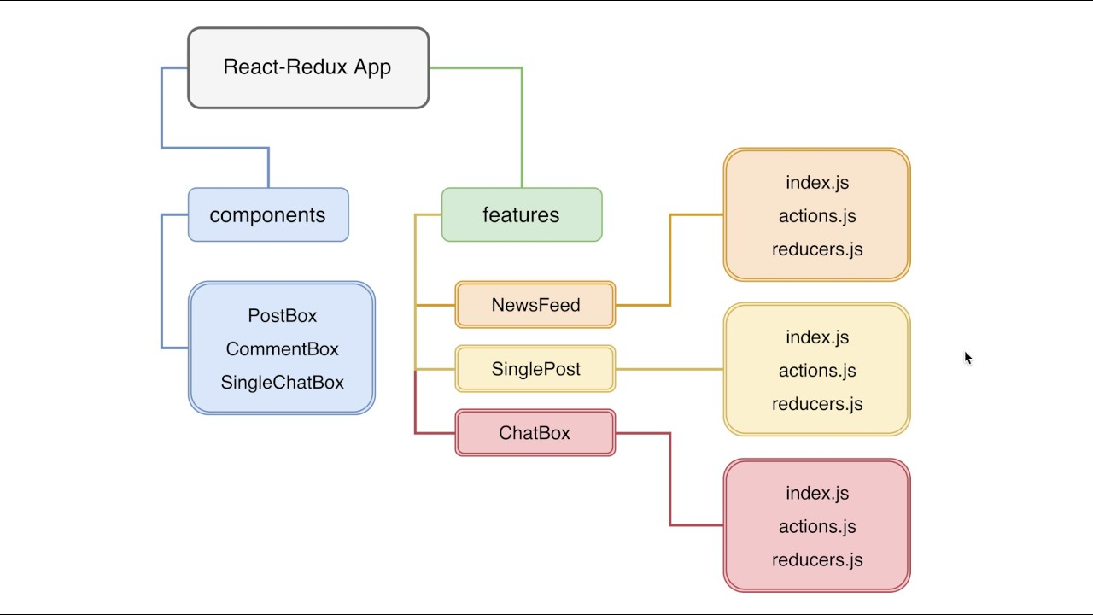

Figure 3. 2 React Architecture

## 3.2 BACKEND

Till now we have completed following languages/frameworks in back-end:

* Node
* SQL
* REST API

### 3.2.1 NODE

Node.js is an open-source, cross-platform, back-end JavaScript runtime environment that runs on the V8 engine and executes JavaScript code outside a web browser. Node.js lets developers use JavaScript to write command line tools and for server-side scripting—running scripts server-side to produce dynamic web page content before the page is sent to the user's web browser. Consequently, Node.js represents a "JavaScript everywhere" paradigm, unifying web-application development around a single programming language, rather than different languages for server-side and client-side scripts.

Node.js has an event-driven architecture capable of asynchronous I/O. These design choices aim to optimize throughput and scalability in web applications with many input/output operations.

The Node.js distributed development project was previously governed by the Node.js Foundation and has now merged with the JS Foundation to form the OpenJS Foundation, which is facilitated by the Linux Foundation's Collaborative Projects program.

### 3.2.2 SQL

Structured Query Language (SQL) is a standardized programming language that is used to manage relational databases and perform various operations on the data in them. Initially created in the 1970s, SQL is extensively used not only by database administrators, but also by developers writing data integration scripts and data analysts looking to set up and run analytical queries.

**SQL is used for the following**:

SQL queries and other operations take the form of commands written as statements and are aggregated into programs that enable users to add, modify or retrieve data from database tables.

A table is the most basic unit of a database and consists of rows and columns of data. A single table holds records, and each record is stored in a row of the table. Tables are the most used type of database objects, or structures that hold or reference data in a relational database. Other types of database objects include the following:

Views are logical representations of data assembled from one or more database tables. Indexes are lookup tables that help speed up database lookup functions. Reports consist of data retrieved from one or more tables, usually a subset of that data that is selected based on search criteria.

### 3.2.3 REST API

An API is a set of definitions and protocols for building and integrating application software. It’s sometimes referred to as a contract between an information provider and an information user—establishing the content required from the consumer (the call) and the content required by the producer (the response). For example, the API design for a weather service could specify that the user supply a zip code and that the producer reply with a 2-part answer, the first being the high temperature, and the second being the low.

In other words, if you want to interact with a computer or system to retrieve information or perform a function, an API helps you communicate what you want to that system so it can understand and fulfill the request.

You can think of an API as a mediator between the users or clients and the resources or web services they want to get. It is also a way for an organization to share resources and information while maintaining security, control, and authentication—determining who gets access to what.

## 3.3 SYSTEM CONFIGURATIONS

The software requirement specification can produce at the culmination of the analysis task. The function and performance allocated to software as part of system engineering are refined by established a complete information description, a detailed functional description, a representation of system behavior, and indication of performance and design constrain, appropriate validate criteria, and other information pertinent to requirements.

**Software Requirements**

* Operating system: Ubuntu 20.04 LTS
* Coding Language: TS, JS, HTML, CSS, ORM, ELASTIC SEARCHING
* Front-End: Visual Studio Code
* Data Base: MYSQL Server MARIADB.
* Postman

**Hardware Requirement**

* System: i5 10th Gen Intel 2.5 GHz
* Ram: 8GB
* SSD: 250GB

## 3.4 USER CHARACTERISTICS

* Geographically: - Indian base.
* Target Audience: - Doctors, Orthodontists, Dentists, B2C Aligner companies.
* Medical Industries.

# CHAPTER – 4 SYSTEM ANALYSIS

## 4.1 STUDY OF CURRENT SYSTEM

Its client requirement-based project development so we need to develop it from scratch. Client wants unique pricing based on doctor’s communication with manufacture. Online Payment handle with Razor Pay integration.

## 4.2 PROBLEM AND WEAKNESSES OF CURRENT SYSTEM

Its client first requirement to develop system so we need to think about design database optimally and right code efficient.

## 4.3 REQUIREMENTS OF NEW SYSTEM

### 4.3.1 FUNCTIONAL REQUIREMENTS

**User Interfaces**

Make user appealing colors and make sure that user can know the flow of system in just one go and don’t have to explain flow.

**Software Interfaces**

The flow must be very smooth, so will use Redux for better user experience.

### 4.3.2 NON-FUNCTIONAL REQUIREMENTS

**Performance Requirements**

The proposed system that we are going to develop will be used as the Management system for providing help to organization to manage their projects.

**Security Requirements**

This web application requires the authentication of users before they use it, and it should never display any personal information to any other users.

## 4.4 FEATURE OF NEW SYSTEM

* We develop new features for system is online payment threw Razor pay. Now a days people want to pay money directly using QR or UPI or Card. So, for secure and easy payment we added this feature.
* Now a days government implant new taxes on products so we create CRUD for that to edit it based on doctor.
* Also, doctor can update delivery address until order status is “Ready for delivery.”
* Amazon SES service for sending mail to notify doctor when order status updated.
* Also provide SMS to doctor for same using Twilio.

## 4.5 FUNCTION OF SYSTEM

**User/Doctor**

* Update his/her details and address.
* Create new patient, update his/her data as well.
* Create new Order for patient and view its details.
* Download order invoice

**Admin**

* CRUD for product, brands, models, trims and addons.
* Create new User, new Sub-admin with proper permissions.
* Download order invoice
* Download all user data and order data in xlsx file.

## 4.6 ACTIVITY DIAGRAM

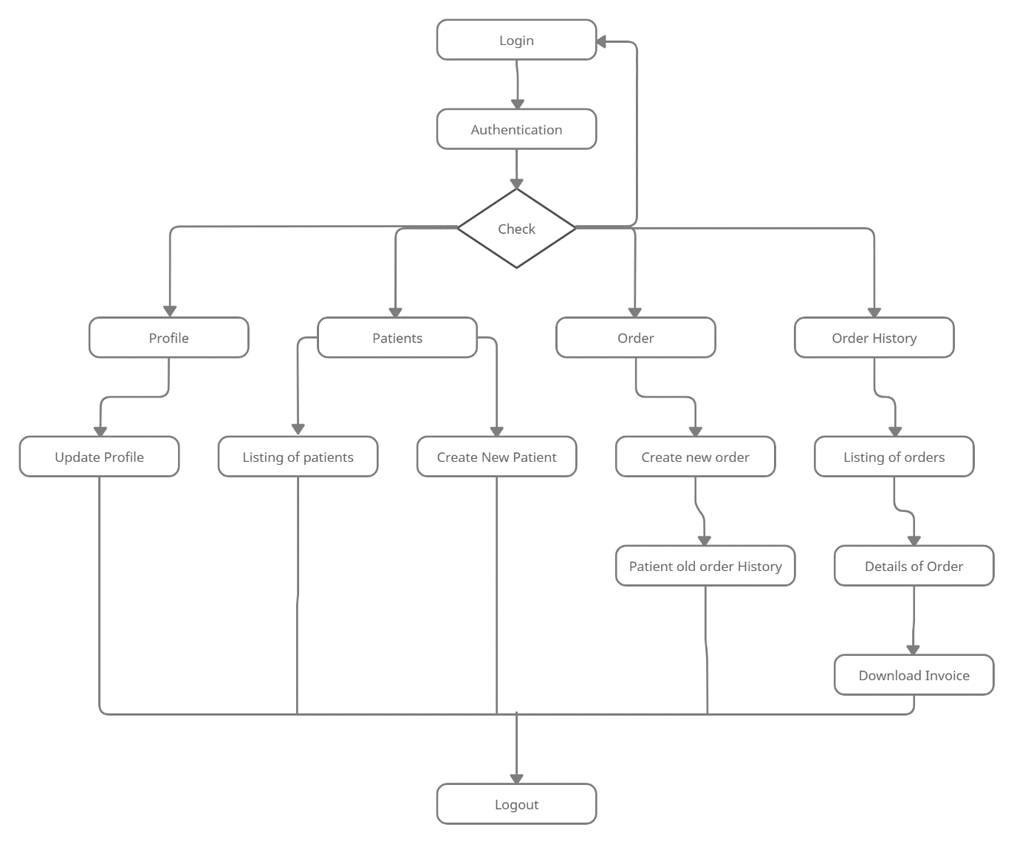

Figure 4. 1 Activity Diagram for Doctors

## 4.7 Use Case Diagram

Figure 4. 2 Use Case Diagram

# CHAPTER – 5 SYSTEM DESIGN AND METHODOLOGY

## 5.1 DATABASE DESIGN

Here I design first models that used by us. There are mainly 4 models that I used for storing system data.

Users Model

* name
* email
* password
* mobile
* is_approved
* is_blocked
* payment_method
* gst_number
* timestamps

Role Model

* id
* name
* slug

UserRole Model

* role_id
* user_id

UserwisePricing Model

* user_id
* productable_id
* productable_type
* price
* custom_price

Orders Model

* product_id
* amount
* shipping_price
* tax
* total_amount
* customer_id
* ordered_on
* delivered_on
* address_id
* patient_id
* trim_di
* instructions
* status
* stl_attachment
* file_attachment

OrderHistory Model

* order_id
* status
* timestamps

OrderDetails Model

* min
* max
* prefix
* model_type_id
* brand_id
* aligner_type_id
* price
* order_id

Invoice Model

* order_id
* payment_mode
* payment_method
* payment_status
* razorpay_order_id
* razorpay_payment_id
* message

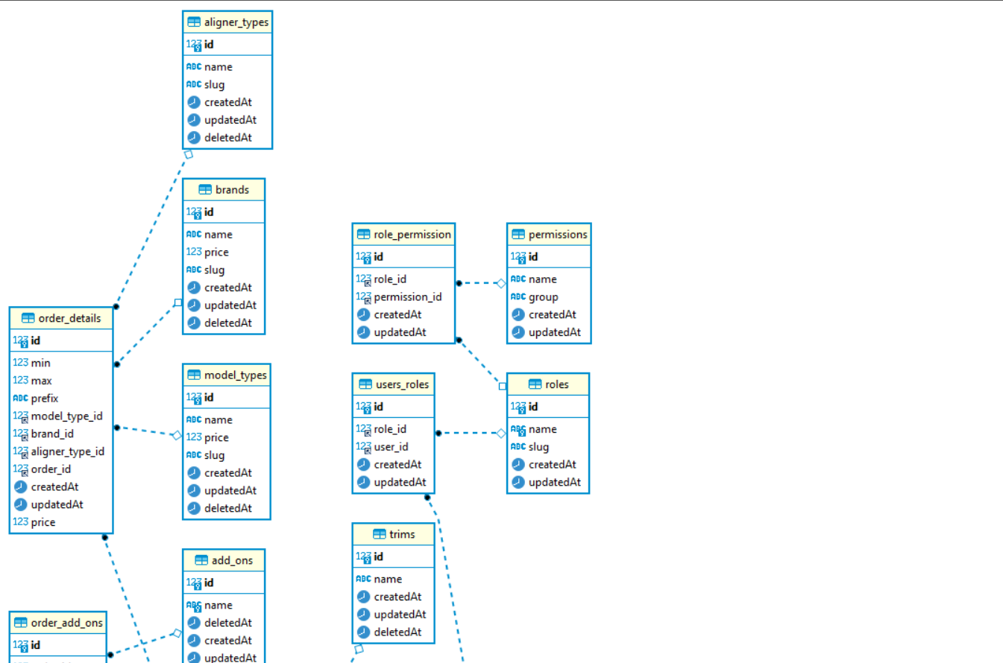

Figure 5. 1 Database Schema

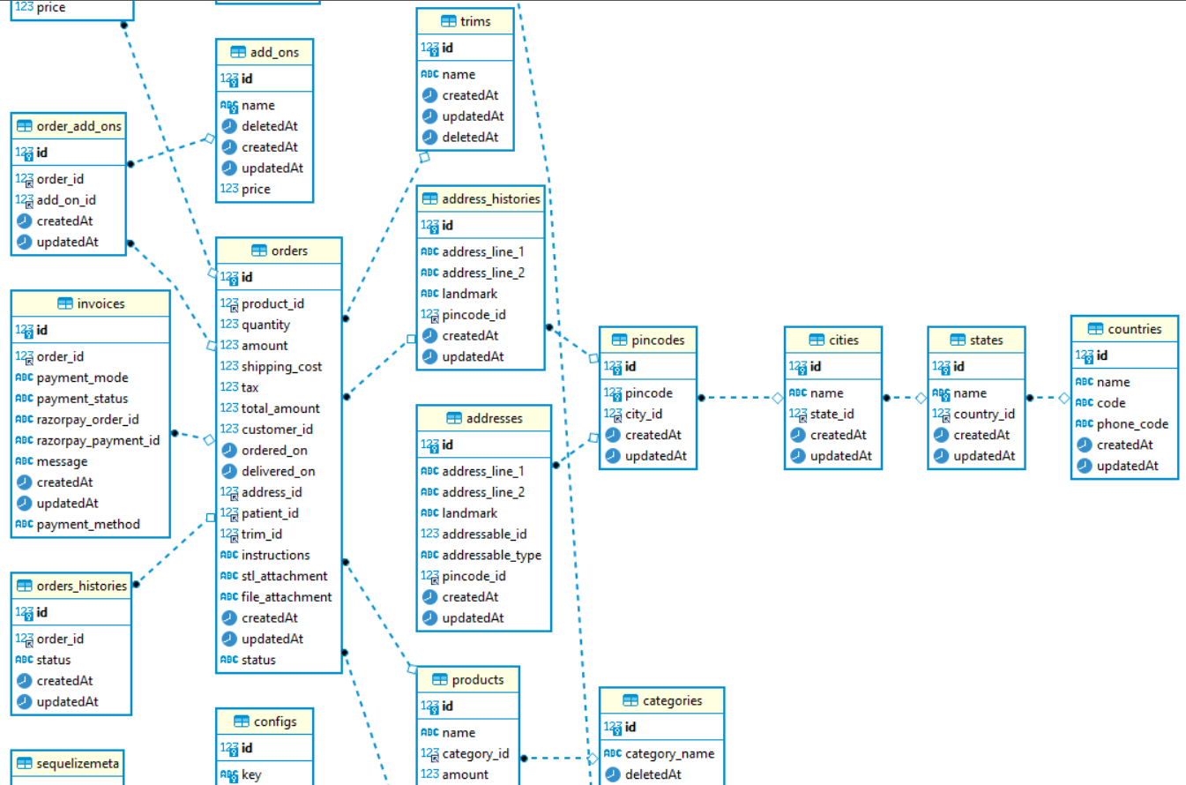

Figure 5. 2 Database Schema

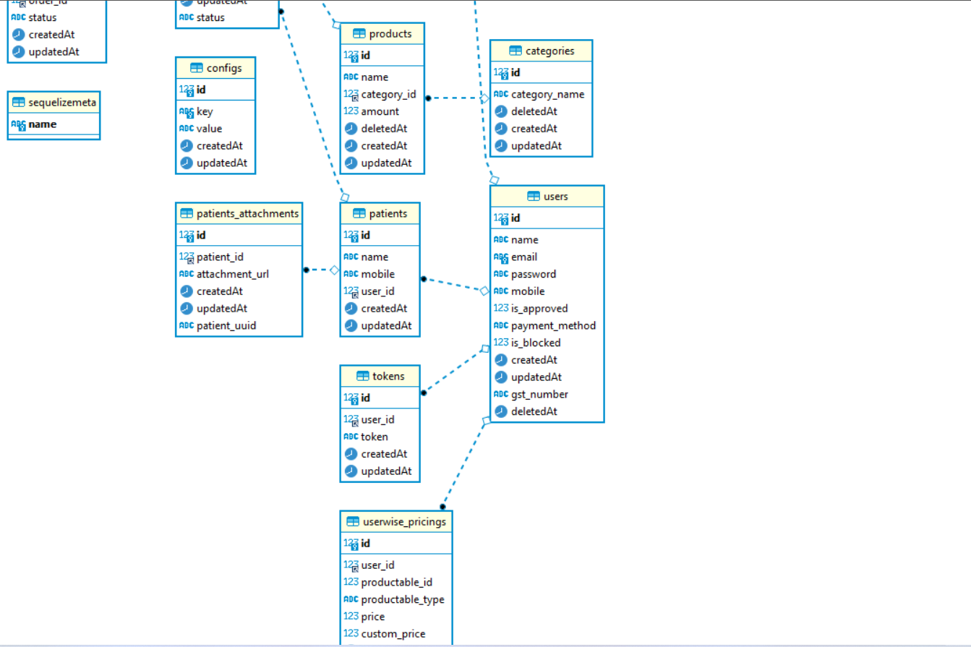

Figure 5. 3 Database Schema

# CHAPTER – 6 IMPLEMENTATION PLANNING

## 6.1 IMPLEMENTATION ENVIRONMENT

This application can be used by multiple users at the same time based on the client requirement.

For that we store multiple tokens for same login person and if anyone try to login from multiple devices than they able to access it. It has graphical user interface, so the client can use this application easily. Users can login through their credentials and need a token to configure the asset for running action.

## 6.2 SECURITY FEATURES

For Accessing this Application, the user needs login credentials and need a token. There are mainly two different users of this projects but based on client requirements we host both doctor and admin part on separate domain.

Also added authorization-based access so that admin can’t be able to login in doctor side same visa se versa.

## 6.3 CODING STANDARDS

To maintain the standards of code in the organization, so its readable and easy to understand for other developers also, PEP 8 is the style guide that is widely used in the JS community. This guide includes rules about naming objects, spacing rules and even how the code is laid out.

**PEP 8 covers many aspects of code readability including:**

Naming Conventions

* + Name variable using snake_case and all lower case
  + Name Classes using camelCase
  + Avoid using single character letters that could be confused with numbers

Documentation Standards for comments

* Comments should have a space after the # sign with the first letter capitalized
* Multi-line comments Used in Functions (docstrings) Should Have a Short Single Line Description Followed by More Text
* Each line of code (as well as comment lines) should be 79 characters wide or less.

Rules for White Space

* Add blank line before a single line comment
* Break up sections of code with white space

# CHAPTER – 7 TESTING

## 7.1 TESTING PLANS

For Testing in Quite Clear Application, the Playbooks are used that can automate the unit testing and give the results. Also, we try to integrate SonarQube for coding standards and code duplication. JEST library used to test the application.

**Playbook overview**

A playbook is used to develop automation strategies. It serves many purposes, ranging from automating small investigative tasks that can speed up analysis to large-scale responses to a security breach.

Using playbooks, we can run multiple actions automatically without any manual supervision. We can also run actions of multiple actions of diﬀerent applications at the same time. Automates the testing and can add more use cases that we can’t perform manually.

**Sanity playbook**

Sanity playbook will always have positive test cases for any actions

## 7.2 TESTING STRATEGY

Unit testing is concerned with testing the smallest modules of the software. For each module, the module's interface is examined to ensure that information properly flows to and from the module. The data structures which are internal to the module should be examined to ensure that they remain in a consistent state as the module is used.

The independent paths through the module should each be tested. Boundary conditions should also be closely examined to ensure that they are properly handled. Importantly, remember to test the error handling code and ensure that they handle and report errors correctly.

Indeed, some software design methods ask for unit tests to be developed before the software itself but for this project, unit tests were written while each module was written.

# CHAPTER – 8 CONCLUSION AND FUTURE WORK

## 8.1 FINDINGS AND CONTRIBUTIONS

My responsibility as an intern is to develop web sites and web applications. I am going to complete my internship program successfully. As an intern I have got opportunity to work with experienced team and I have learned a lot from the team.

At first, I have gotten the knowledge about how to work with a team and how to divide the task and completed the responsibility. I also learn many important points to be a full stack developer.

I have lot of limitations and very little knowledge about developing. Now I am able to fix my limitations and I have learned how to work on a cross platform.

## 8.2 PROBLEM ENCOUNTERED AND POSSIBLE SOLUTIONS

**Problems:**

* At start of this internship, I had some problems regarding how company works and how I will I ask about my doubts?
* At back-end side how to arrange folders and how to manage it?
* Some issues with csv data parsing.
* Design web pages from scratch and give them real nice look and rich feel
* How to think from user perspective and try to find problem

**Solutions:**

* My seniors are we kind and always ready to help they regularly ask about any doubt I have and try to solve it.
* At back-end side our mentors regularly arranged sessions to design and manage structure of project.
* Internet is the best helper and guide for us it helped me to solve csv parsing problem
* For web page design it’s all about practice it will make better as we do practices and try different solutions
* To view problem as user perspective I followed some tips from my mentors and also tried to take some reviews from peoples which are actual users.

## 8.3 RECOMMENDATION FOR FUTURE WORK

As an intern I have some limitations to do my responsibility completely. I mainly worked on the user panel of the project and currently working on admin panel. I already fix my limitation and try to develop my skill higher.

The project is currently completed but client want to add some new functionality, so we gave him estimation and after conformation we start implementing new features on application.

## 8.4 COMPANY FEEDBACK

# CHAPTER – 9 REFERENCE

**Links:**

* [Documentation | Node.js (nodejs.org)](https://nodejs.org/en/docs/)
* [Express 5.x - API Reference (expressjs.com)](https://expressjs.com/en/5x/api.html)
* [Lodash Documentation](https://lodash.com/docs/)
* [Getting Started – React (reactjs.org)](https://reactjs.org/docs/getting-started.html)
* [Getting Started | Redux Toolkit (redux-toolkit.js.org)](https://redux-toolkit.js.org/introduction/getting-started)
* [Getting Started | Sequelize](https://sequelize.org/docs/v6/getting-started/)
* [Model Basics | Sequelize](https://sequelize.org/docs/v6/core-concepts/model-basics/#data-types)
* [Jira | Issue & Project Tracking Software | Atlassian](https://www.atlassian.com/software/jira)
* [Asana Project Management Software. Teams don’t lose track of work with Asana. • Asana](https://asana.com/campaign/fac/think?&utm_campaign=Brand--SA--EN--Core--All-Device--Exact&utm_source=google&utm_medium=pd_cpc_br&gclid=CjwKCAjwu_mSBhAYEiwA5BBmf85cMq0ZBtZAFmH7vn1SBLD3PEtsIv62rNC9-k_sXFU2fzXhkIFpPRoCP_sQAvD_BwE&gclsrc=aw.ds)